High level steps changing sanding paper:
https://youtu.be/PgoNGdh6WxA?si=Yih8Wm0w9d3xKbzU&t=239

- Remove Sanding Paper by getting of half of the round sanding paper.
- Add the helper tool (half circle old sanding paper)
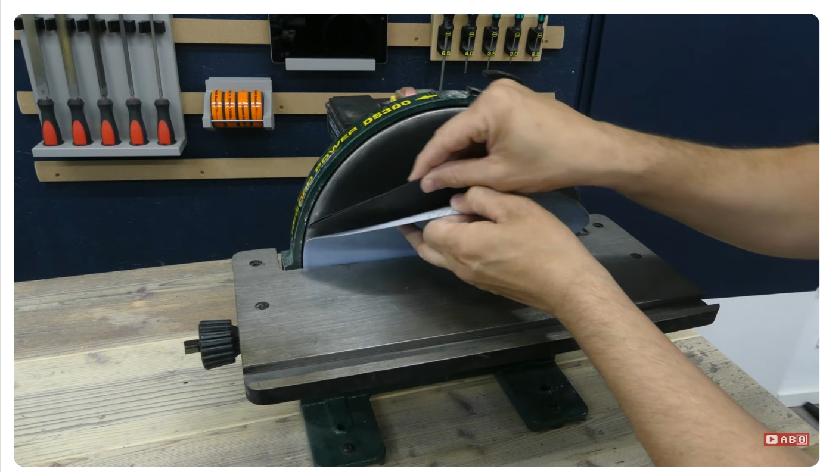
Helper tool
- Spin the wheel
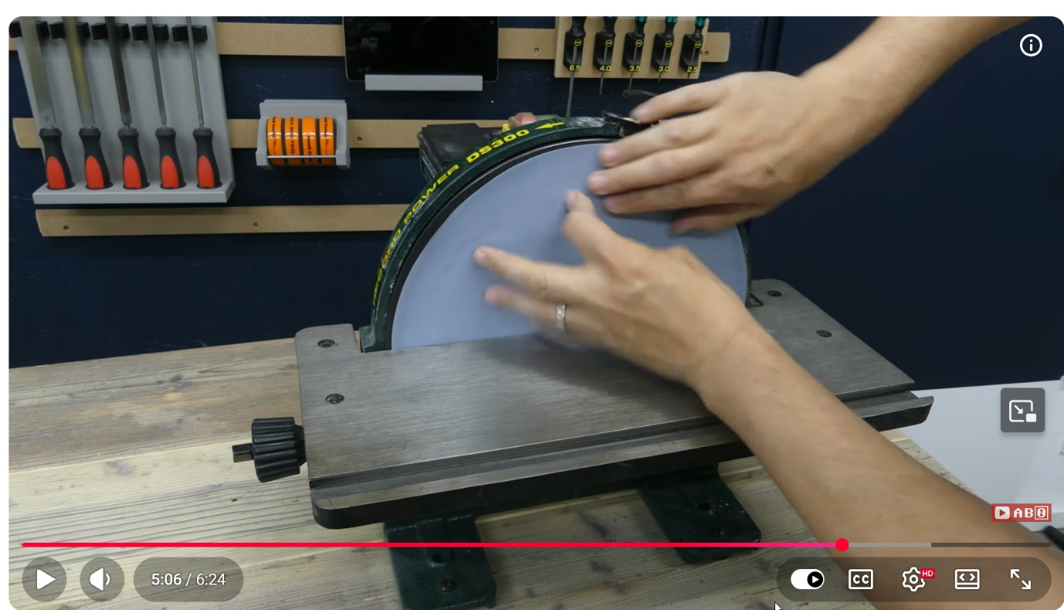
- Remove the sanding paper completely
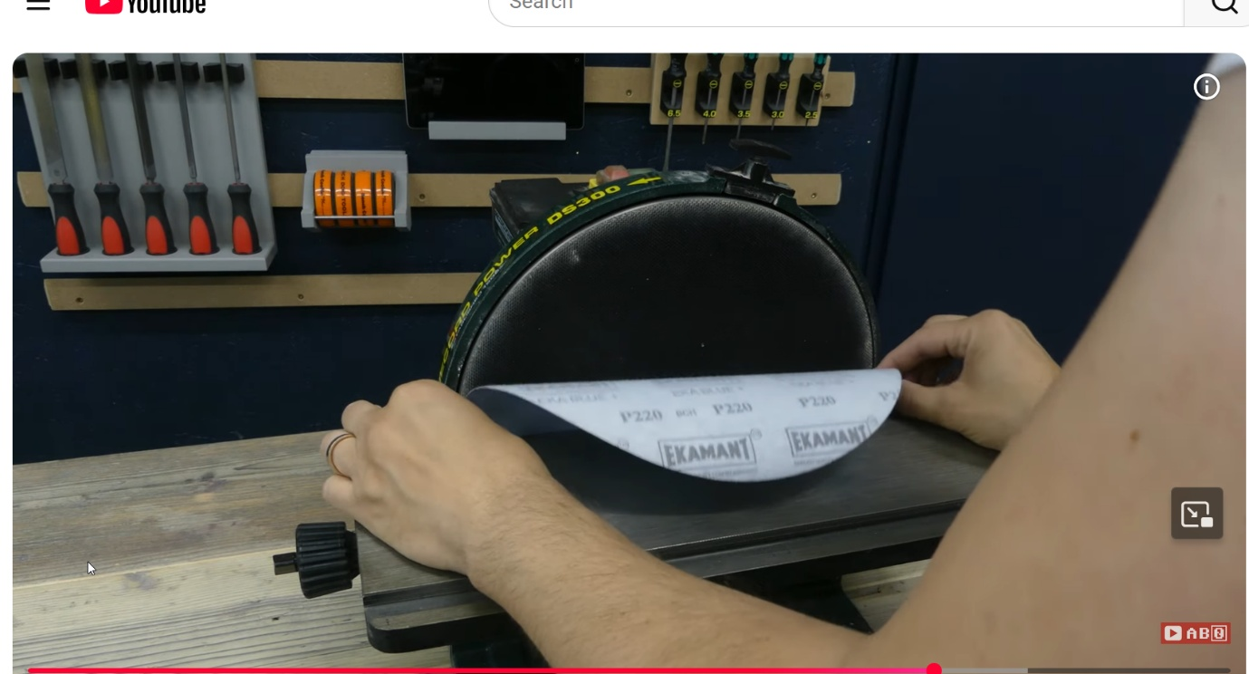
- Add the new sanding paper (only half side connects)
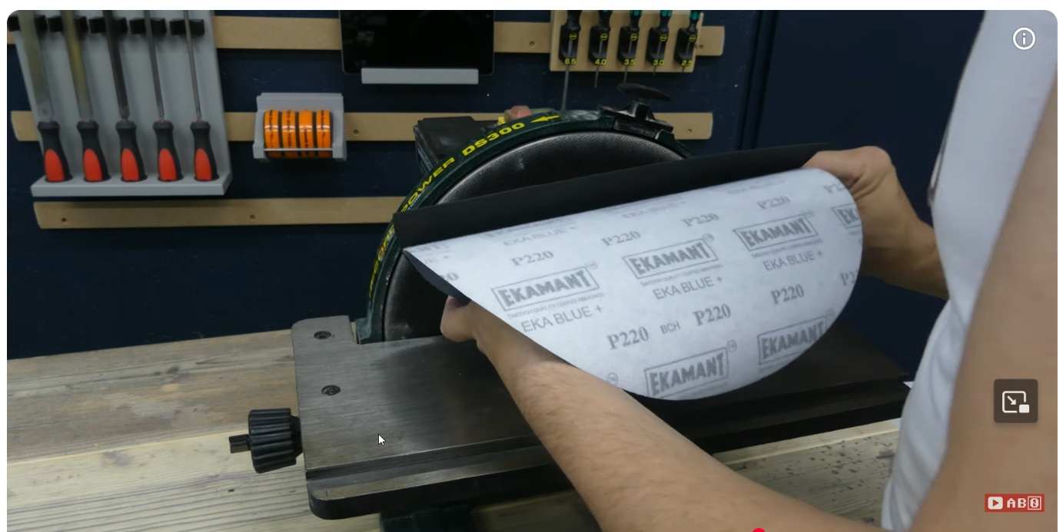
- Spin the wheel
- Remove the helper tool
- Fix the remaining part of the new sanding paper

